Module – 4

**1.What are the main factors that can affect PPC bidding?**

**Answer:**

1. Keyword competition: High-demand keywords cost more.
2. Quality Score: Better quality = lower cost per click.
3. Ad relevance: How relevant your ad is to the keyword.
4. Landing page experience: A good landing page helps reduce costs.
5. Ad format & extensions: Use of sitelinks, callouts, etc. improves CTR.
6. Bid strategy: Manual vs. automated bidding methods.
7. Device targeting: Bids can vary for mobile vs. desktop.
8. Location and time: Bids change based on user’s location and time of day.

**2. How does a search engine calculate actual CPC?**

**Answer:**

Actual CPC = (Ad Rank of the competitor below you / Your Quality Score) + $0.01

* You only pay the minimum required to beat the advertiser just below you.
* So even if you bid high, your actual CPC may be much lower depending on the competition and your Quality Score.

**3. What is a Quality Score and why is it important for Ads?**

**Answer:**

Quality Score is a rating (1 to 10) given by Google based on:

1. Expected click-through rate (CTR)
2. Ad relevance to the keyword
3. Landing page experience

🔹 Why it’s important:

* Higher Quality Score = Lower CPC
* Better ad position
* Improves your ad performance overall
* Saves money while increasing visibility

2. Create an ad for your website/ blog in Google Ads that display on the display network

with

the properly targeted audience

step 1

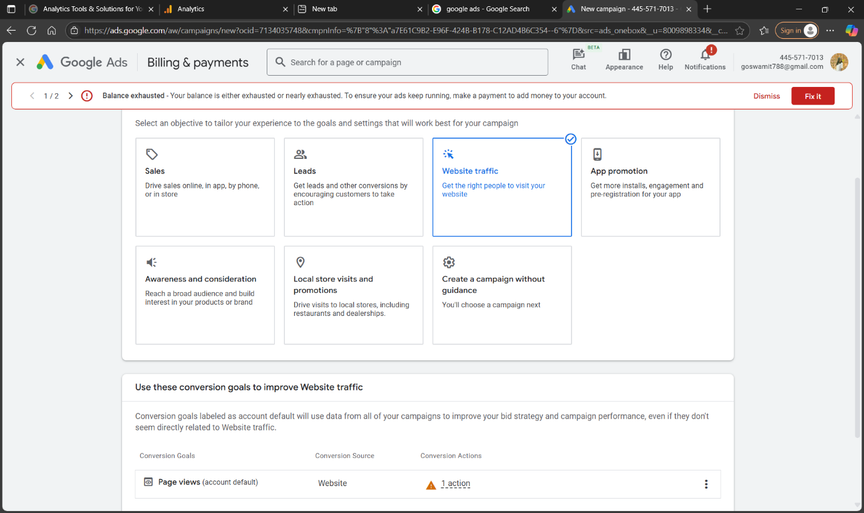

Step 2

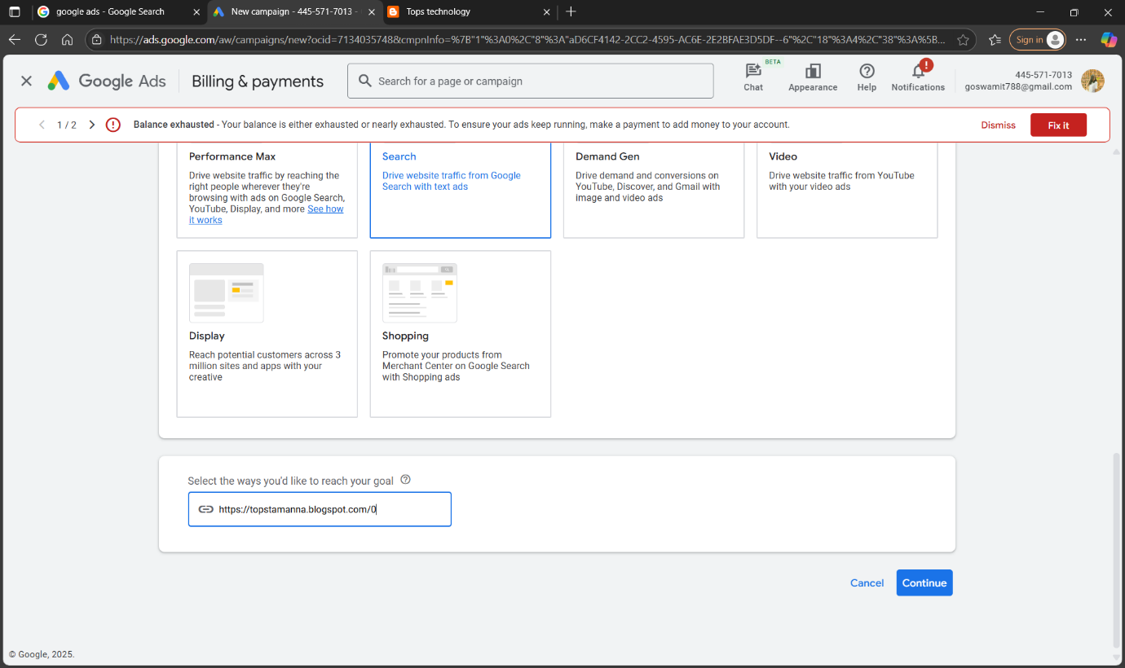

Step 3

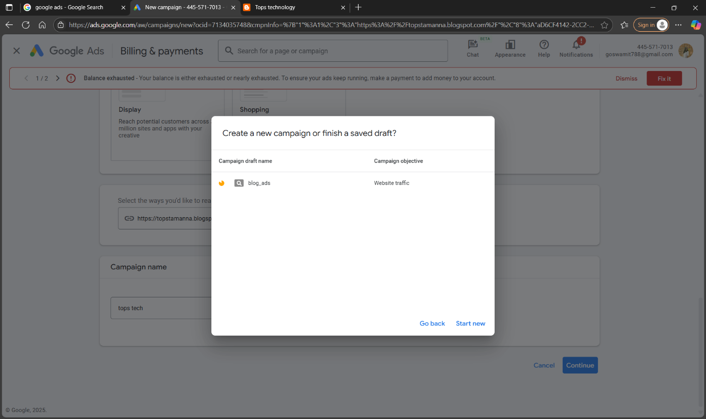

Step 4

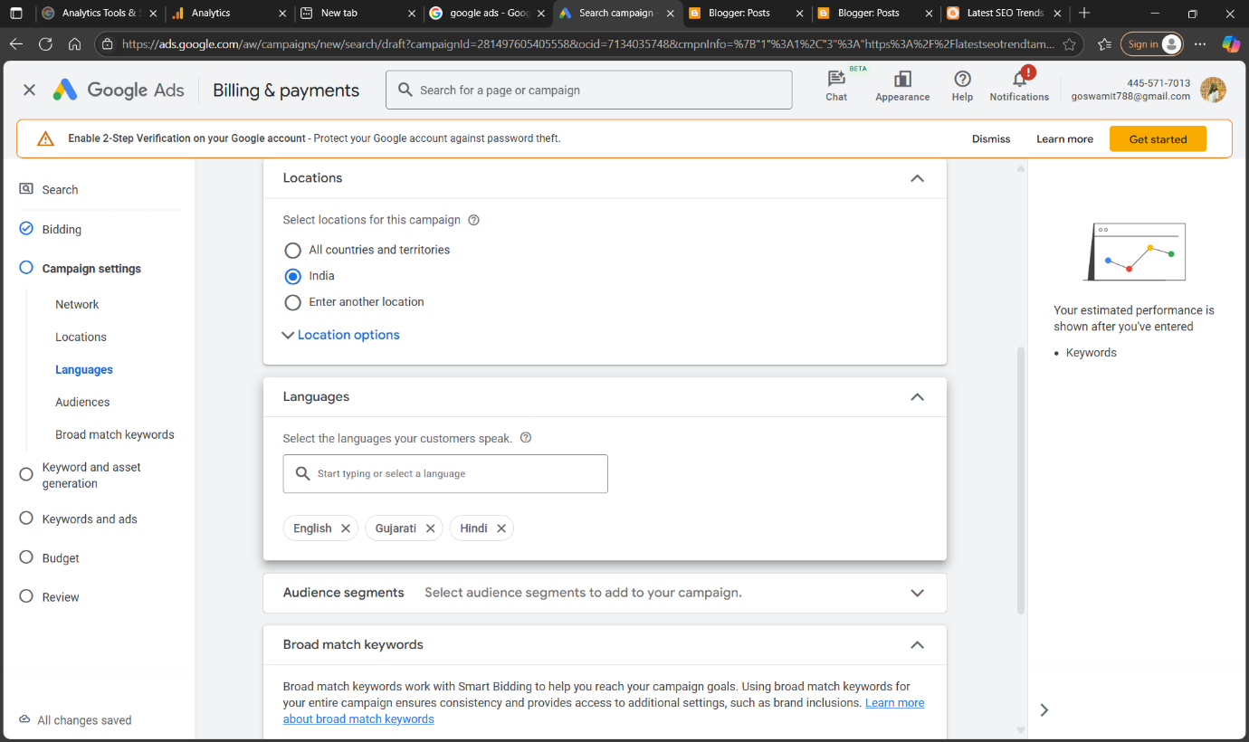

Step 5

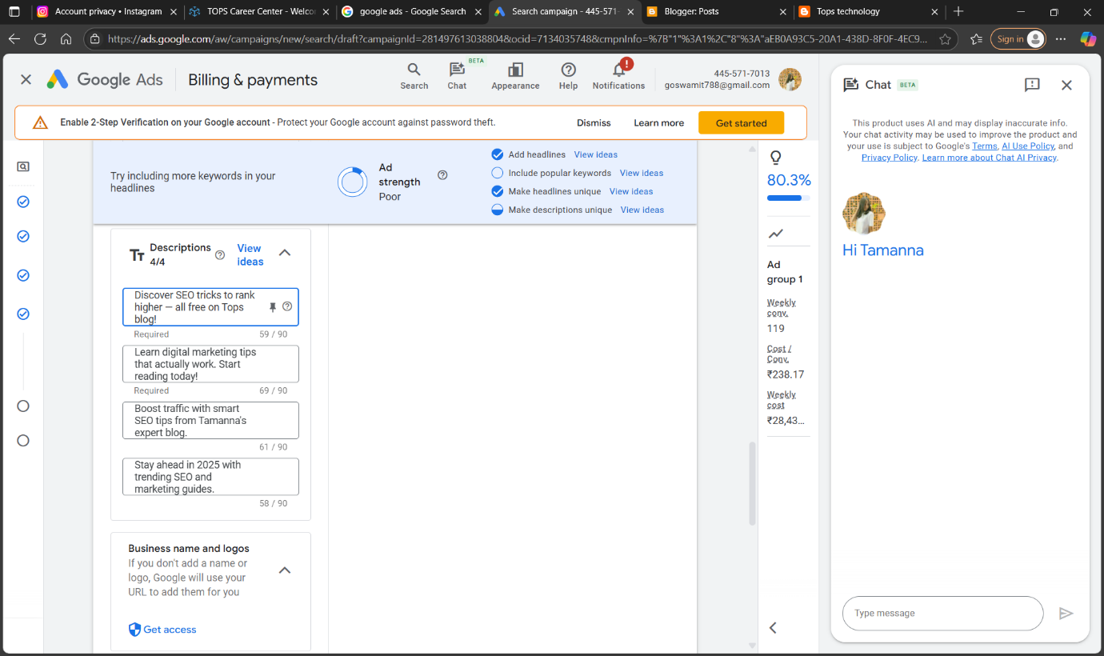

Step 6

